**College : Vishwakarma Institute of Technology**

**Name : Vedika Vikas Sontakke**

**Roll no : 37**

**PRN No : 1222006**

**Course : Data Structure**

**Assignment No 1 Problem Statement 7**

* **Quick Sort**
* **Aim :**

WAP to implement Quick Sort on 1D array of Employee

structure (contains employee_name, emp_no, emp_salary), with key as

emp_no. And count the number of swap performed.

* **Program :**

/*

WAP to implement Quick Sort on 1D array of Employee

structure (contains employee_name, emp_no, emp_salary), with key as

emp_no. And count the number of swap performed.

*/

#include<stdio.h>

#include <string.h>

int count_swap = 0;

struct Employee

{

    char employee_name[40];

    int emp_no;

    int emp_salary;

};

void swap(struct Employee *emp_array , int x  , int y)

{

    struct Employee temp;

    temp = emp_array[x];

    emp_array[x] = emp_array[y];

    emp_array[y] = temp;

    count_swap++;

}

void quick_sort(struct Employee emp_array[] , int first , int last)

{

    int i , j , pivot;

    if(first < last){

    i = first;

    j = last;

    pivot = first;

    while(i < j)

    {

       while(emp_array[i].emp_no <= emp_array[pivot].emp_no && i<last)

         i++;

       while(emp_array[j].emp_no > emp_array[pivot].emp_no)

         j--;

       if(i < j) swap(emp_array , i , j);

    }

    swap(emp_array , j , pivot);

    // for left digits

    quick_sort(emp_array , 0 , pivot-1);

      // for right digits;

    quick_sort(emp_array , pivot+1 , last);

    }

}

int main()

{

    int size ;

    printf("enter the size of the array \n");

    scanf("%d",&size);

    struct Employee emp_array[size];

    printf("enter the employee no , employee name , employee salary :");

    for(int i=0 ; i<size ; i++)

       scanf("%d %s %d" , &emp_array[i].emp_no , &emp_array[i].employee_name , &emp_array[i].emp_salary);

    quick_sort(emp_array , 0 , size-1);

    printf("number of swaps are : %d" , count_swap);

    printf("\n print the employee no , employee name , employee salary  after sorting :");

    for(int i=0 ; i<size ; i++)

       printf("\n %d %s %d ",emp_array[i].emp_no,emp_array[i].employee_name , emp_array[i].emp_salary);

    return 0;

}

**Output :**

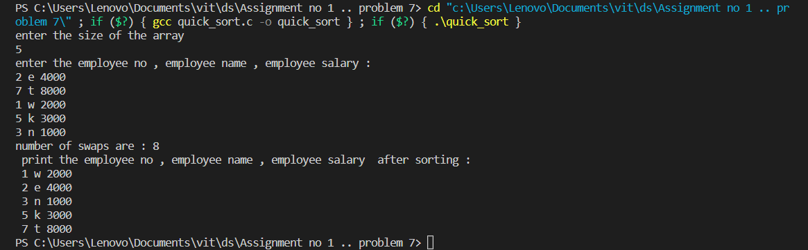

* **Merge Sort**
* **Aim :**

WAP to implement Merge Sort on 1D array of Employee

structure (contains employee_name, emp_no, emp_salary), with key as

emp_no. And count the number of swap performed.

* **Program :**
* /*
* WAP to implement Merge Sort on 1D array of Employee
* structure (contains employee_name, emp_no, emp_salary), with key as
* emp_no. And count the number of swap performed.
* */
* #include<stdio.h>
* void merge_sort();
* void merge();
* int count_swap = 0;
* struct Employee
* {
* char employee_name[40];
* int emp_no;
* int emp_salary;
* };
* int main()
* {
* int size;
* printf("enter the size of the array \n");
* scanf("%d",&size);
* struct Employee emp_array[size];
* printf("enter the employee no , employee name , employee salary :");
* for(int i=0 ; i<size ; i++)
* scanf("%d %s %d" , &emp_array[i].emp_no , &emp_array[i].employee_name , &emp_array[i].emp_salary);
* merge_sort(emp_array , 0 , size-1);
* printf("count number of swaps %d", count_swap);
* printf("\nprint the employee no , employee name , employee salary  after sorting :");
* for(int i=0 ; i<size ; i++)
* printf("\n %d %s %d ",emp_array[i].emp_no,emp_array[i].employee_name , emp_array[i].emp_salary);
* return 0;
* }
* void merge_sort(struct Employee emp_array[], int first , int last)
* {
* int mid ;
* if(first < last)
* {
* mid = (first+last)/2;
* merge_sort(emp_array , first , mid);
* merge_sort(emp_array , mid+1 , last);
* merge(emp_array , first , mid , last);
* }
* }
* void merge(struct Employee emp_array[], int first , int mid , int last)
* {
* struct Employee b[50];
* int i , j , k;
* i = first ;
* j = mid+1;
* k = first;
* while(i<=mid && j<=last)
* {
* if(emp_array[i].emp_no <= emp_array[j].emp_no)
* {
* b[k++] = emp_array[i++];
* count_swap++;
* }
* else {
* b[k++] = emp_array[j++];
* count_swap++;
* }
* }
* if(i>mid)
* {
* while(j<=last){
* b[k++]= emp_array[j++];
* count_swap++;
* }
* }
* else{
* while(i<=mid){
* b[k++] = emp_array[i++];
* count_swap++;
* }
* }
* for( i=first ; i<=last ; i++)
* emp_array[i] = b[i];
* }
* **Output :**

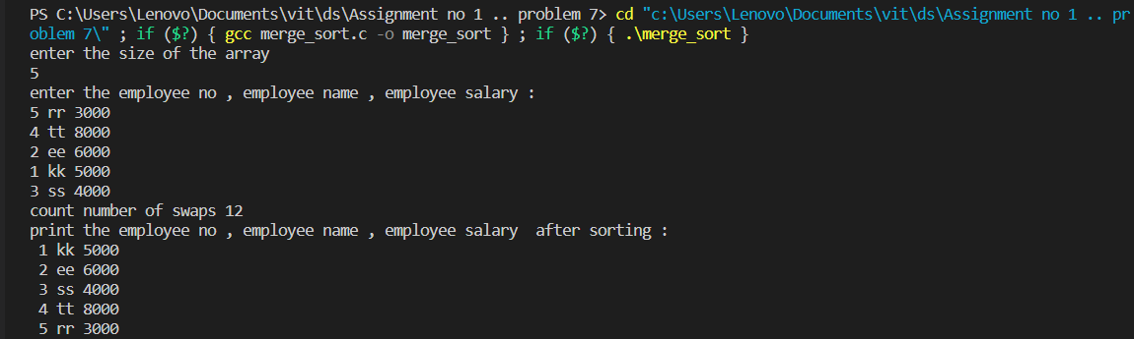

* **Heap Sort**
* **Aim :**

WAP to implement Heap Sort on 1D array of Employee

structure (contains employee_name, emp_no, emp_salary), with key as

emp_no. And count the number of swap performed

* **Program :**

/*

WAP to implement Heap Sort on 1D array of Employee

structure (contains employee_name, emp_no, emp_salary), with key as

emp_no. And count the number of swap performed.

*/

#include<stdio.h>

void heap_Sort();

void heapify();

int count_swap = 0;

struct Employee

{

    char employee_name[40];

    int emp_no;

    int emp_salary;

};

int main()

{

    int size;

    printf("enter the size of the array \n");

    scanf("%d",&size);

    struct Employee emp_array[size];

    printf("enter the employee no , employee name , employee salary :");

    for(int i=0 ; i<size ; i++)

       scanf("%d %s %d" , &emp_array[i].emp_no , &emp_array[i].employee_name , &emp_array[i].emp_salary);

    heap_Sort(emp_array , size);

     printf("count number of swaps are %d", count_swap);

    printf("\nprint the employee no , employee name , employee salary  after sorting :");

    for(int i=0 ; i<size ; i++)

       printf("\n %d %s %d ",emp_array[i].emp_no,emp_array[i].employee_name , emp_array[i].emp_salary);

    return 0;

}

void swap(struct Employee *emp_array , int x  , int y)

{

    struct Employee temp;

    temp = emp_array[x];

    emp_array[x] = emp_array[y];

    emp_array[y] = temp;

    count_swap++;

}

void heapify(struct Employee emp_array[], int size, int i)

{

    //  largest among root, left child and right child

    int largest = i;

    int left = 2 * i + 1;

    int right = 2 * i + 2;

    // If left child is larger than root

    if (left < size && emp_array[left].emp_no > emp_array[largest].emp_no)

        largest = left;

    // If right child is larger than largest

    if (right < size && emp_array[right].emp_no > emp_array[largest].emp_no)

        largest = right;

    // Swap and continue heapifying if root is not largest

    if (largest != i) {

        swap(emp_array , i , largest);

        // Recursively heapify the affected sub-tree

        heapify(emp_array, size, largest);

    }

}

 void heap_Sort(struct Employee emp_array[], int size)

{

    // Build max heap

    for (int i = size / 2 - 1; i >= 0; i--)

        heapify(emp_array, size, i);

    // Heap sort

    for (int i = size - 1; i >= 0; i--) {

        swap(emp_array , 0 , i);

        // Heapify root element to get highest element at root again

        heapify(emp_array, i, 0);

    }

}

* **Output :**

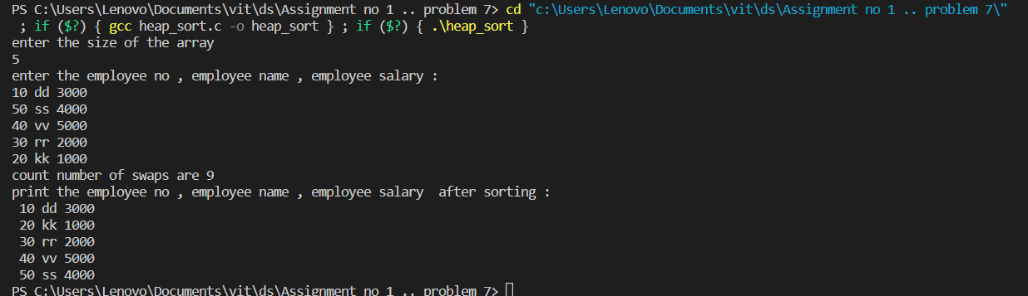

**-THANK YOU**